**Wine & Beer**

**White**

Montinore Pinot Gris, 2016, Oregon

9 | 32

Matua Sauvignon Blanc, 2016, New Zealand

7 | 26

Frog’s Leap Chardonnay, 2015, Napa Valley

11 | 42

Pine Ridge Chenin Blanc, 2017, Napa Valley

8 | 30

Dr. Loosen Riesling Mosel, 2016, Germany

8 | 30

Montinore Northern Whites Blend, Oregon

9 | 32

**Red**

Etude Lyric Pinot Noir, 2015, Santa Barbara

9 | 34

Argento Malbec, 2016, Argentina

8 | 30

Frey Organic Natural Red, 2016, Mendocino

7 | 26

Sterling Merlot, 2014, Napa Valley

10 | 38

Dry Creek Cabernet Sauvignon, 2015, Sonoma

10 | 38

Marietta Christo, 2014, Sonoma

8 | 30

**Dessert Wines**

Graham’s Tawny 10-year, Portugal

15 | 54

Glacier Bear Red Raspberry, 2016, Homer AK

*Alaska Grown

12 | 44

Smith Woodhouse, 2003, Portugal

15 | 54

**Mimosa**

Brut Champagne | Orange Juice

8

**On Tap**

We showcase seasonal and rotating taps, ask your server for current selections

Bleeding Heart Brewery, Palmer, Alaska

Arkose Brewery, Palmer, Alaska

Matanuska Brewing Co, Palmer, Alaska

Bear Paw River Brewing Co, Wasilla, Alaska

Midnight Sun Brewing Co, Anchorage, AK

Pint – 7

We support sustainability!

Knik River Lodge sources wines from eco- friendly vineyards using organic grapes whenever possible.

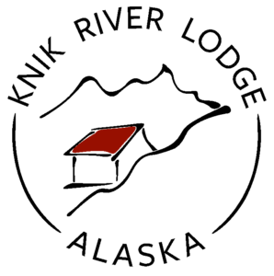

**Appetizers and Salad**

Bacon Wrapped Dates

gorgonzola stuffed | balsamic syrup

10

Alaskan Sliders

Hawaiian rolls | fresh Alaskan fish | slaw | remoulade sauce

16

Nachos

braised chicken **|** pickled jalapeño | sautéed onions | tomato | blended cheese | salsa

15

Arctic Organics Caesar Salad

romaine | caesar | garlic crouton |lemon wedge | tomato | asiago |parmesan

13

**Knik River Lodge makes every possible effort to use local ingredients. We believe in supporting farmers, our community and buying local. We are proud to work with these local businesses**

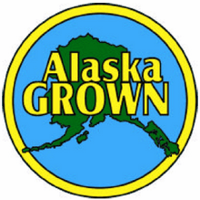

Arctic Organics – Butte, Alaska

Synergy Gardens and Alaska Garlic Project – Homer, Alaska

Pyrah’s Pioneer Peak Farm – Butte, Alaska

Rempel Family Farms – Butte, Alaska

Misty Mountain Farms – Delta Junction, Alaska

Alaska Flour Company – Delta Junction, Alaska

Bleeding Heart Brewery – Palmer, Alaska  
Arkose Brewery – Palmer, Alaska

VanderWeele Farms – Palmer, Alaska

Consuming **raw or undercooked** meats, poultry, seafood, shellfish, or eggs may increase your risk of foodborne illness